Hometask
Testing of vacuum cleaner

Subject of testing: Vacuum cleaner  Mark: Bosh  Model: GS 10  Was tested by Maksym Kovalchuk and Oleksandr Svystun | 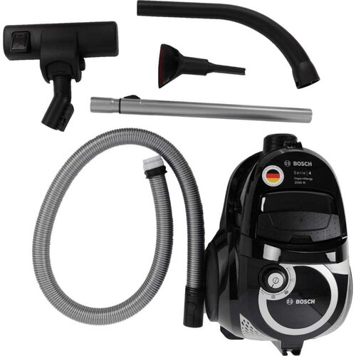

Functional suitability
Functional Completeness:
The functional tasks of vacuum cleaner is cleaning up dirt/particles and dust from different surfaces. This model successfully complies with those requirements.
Functional Correctness:
Dry cleaning of different surfaces by vacuuming it. Works well, good in cleaning flat surfaces from dust, little participles, hairs, fur, etc.
Big participles of mud and spots are hard to remove; wet cleaning is not available.
Functional Appropriateness:
Enough functional and comfortable for average apartments cleaning up. Also can be used for cleaning car from dust and little participles. No need to buy further nozzles and bags.

Performance efficiency
Time Behavior: Vacuuming of 40 sq.m will take about 15 minutes. This model is very lightweight, has three wheels, what makes working with it much easier and faster.
Resource utilization: This model of vacuum cleaner is energy efficient, with reusable trash container which helps to save your money and is eco-friendly. The cost of this model is about 100-120 $, the price is appropriate for the requirements and functions.
Capacity: Maximum capacity of trash container is about 1,5-2 liters.

Compatibility

Co-existence: Works from the socket, has long cable. It has few nozzles that helps you to clean different surfaces – floor, carpets, furniture.
Can vacuum little things that lying on the floor or on furniture like jewelries or money, so you can throw them away by mistake.
Interoperability: Suitable for use in small, average and big flats, houses, and also in outdoor for cleaning car.

Usability

Appropriateness/Recognizability: Customer can determine what vacuum cleaner they need with the following characteristics: type of cleaning, energy of working, power of vacuuming, capacity of trash container, size, materials, modern design.
Learnability: Customer can easily learn how to use this vacuum cleaner. It has pictures on it which show customers how to operate right.
Operability: It has only two buttons – first for turn it on and to choose level of vacuuming; second for taking cable back into the vacuum cleaner. Buttons and levels of vacuuming has understandable design and easy to operate. It has three wheels that helps vacuum cleaner easy to move, lightweight materials and hose with possibility of size changing fits everyone.
User error protection: The cleaner is not well protected against user errors. Possible bugs can appear if user forgets to put in trash container correctly, before turning vacuum cleaner on.
User interface aesthetics: Appearance of the vacuum cleaner can satisfy users. It is suitable for both men and women.
Accessibility: The vacuum cleaner can be used by anybody, regardless of the country of stay and language of communication. But in countries with different type of sockets customer might have to buy an adapter.

Reliability

Maturity: the vacuum cleaner is reliable under normal conditions.
Availability: If a user has purchased a vacuum cleaner, is always
available with an electricity source
Fault іtolerance: the vacuum cleaner is dependent of external factors.
Mechanical damage, wet environment can make it impossible to perform basic functions.
Recoverability: If someone turns off the electricity, you can continue to use the vacuum cleaner after turning it on

Security

Confidentiality: Everyone has access to a vacuum cleaner, but to access the inside part of the vacuum cleaner, only persons with a specific set of tools.
Integrity: Thanks to screws and bolts, unauthorized users will not be able to replace or pick up items from there
Non-repudiation:If an unauthorized person has the necessary tools to open the inside of the vacuum cleaner, we will be able to prove that the internal component was replaced or stolen when the vacuum cleaner was first opened thanks to a broken warranty seal.
Accountability: It is possible to determine the subject's actions, but to determine who it was, perhaps only by fingerprints
Authenticity: It is possible to determine the subject's actions, but to determine who it was, perhaps only by fingerprints.

Maintainability

Modularity: Correct replacement of certain parts of the vacuum cleaner does not affect performance and the work of other details
Reusability: Vacuum cleaner can be used many times.
Analysability: For the analysis of the product requires a complete knowledge of the scheme of the internal structure of the vacuum cleaner. Self-replacement of parts is possible only with the necessary tools and skills
Modifiability: If the vacuum cleaner needs repair, contact a service center. Self-repair or modification by the user may cause the vacuum cleaner to malfunction.
Testability: It is easy to test the vacuum cleaner in operation, but test that the inside part of the vacuum cleaner is fully functional we can only with special tools.

Portability
Adaptability :The vacuum cleaner works effectively with all users in a dry environment.
Installability:The vacuum cleaner can be easily placed anywhere because it is not too big.
Replaceability : Another vacuum cleaner,or the same or with different characteristics, may replace yours if it does not perform its functions properly.

2. List of Testing Types, which can be applied for vacuum cleaner quality verification, and description of a test for each of Testing Types

Functional testing
1. Check that the vacuum cleaner sucks the dust well enough;
2. Can you properly clean the desired surfaces with a vacuum cleaner?
Non-functional Testing
1. The appearance of the vacuum cleaner;
2. Main part, retractable handle, nozzle for the desired type of cleaning, three wheels, electric plug.
Exploratory Testing
Instructions for use are included with the vacuum cleaner.
Manual Testing
We will be able to test the vacuum cleaner both manually and with the help of special devices (check voltage, amperage, retraction force, etc.)
Positive Testing
Connect the vacuum cleaner to the power source, turn on, collect dust and dirt
Negative Testing
Try to clean the wet surface with a vacuum cleaner, remove a large piece of dirt, operate the vacuum cleaner without connecting to a power source.

